
Make the TECHTONIC-LAB in all caps everywhere in the website wherever mentioned

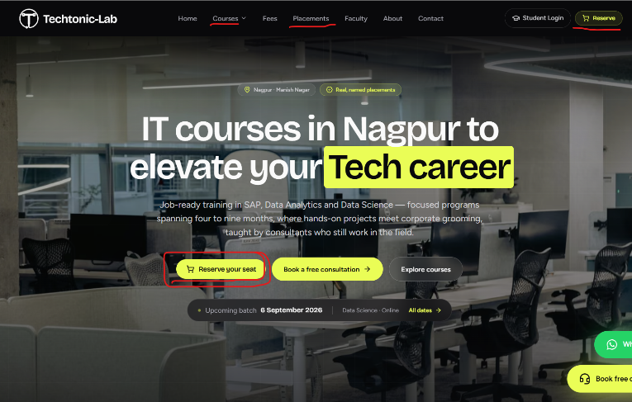

Remove this reserve your seat button next to
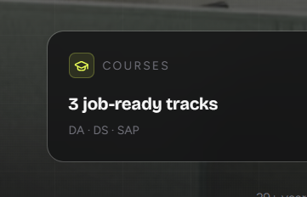
Book a consultation as it in the right top corner also

Make it 6 Job ready tracks
Data Analytics
Data science
SAP MM
SAP FICO
SAP SD
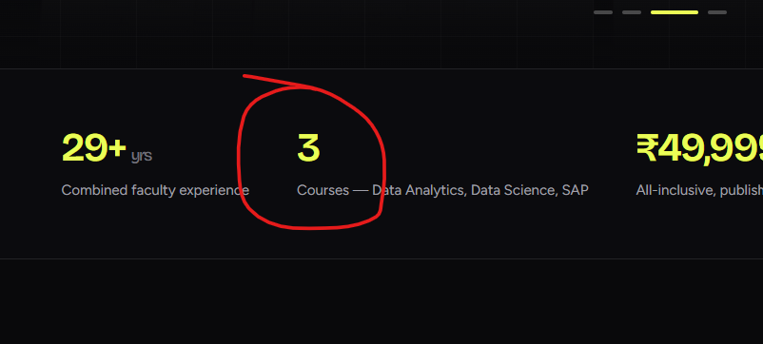
SAP PPQM

Here also
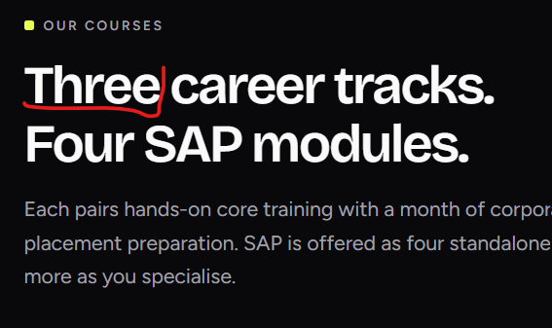

Make the size font and box size both same for All course modules
I know they are different but make sure the size for both looks the same to make sure It looks uniform
also like MM FICO buttons make power Bi, SQL, Excel buttons for all and there basic details like we did for SAP

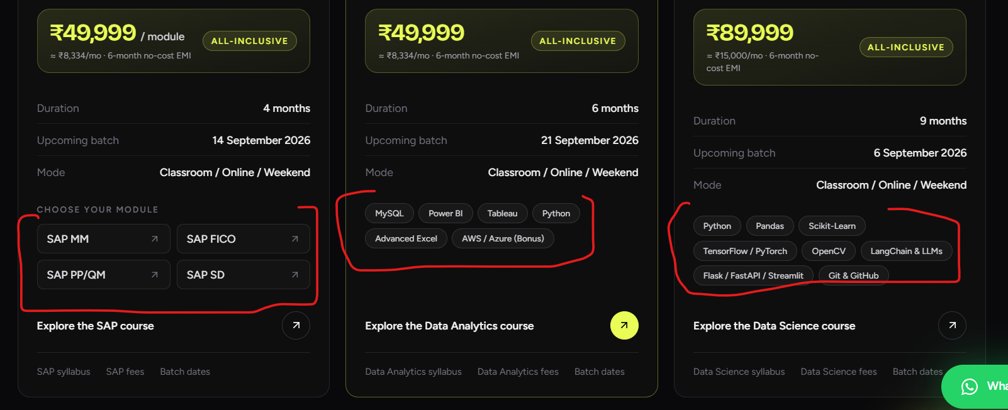

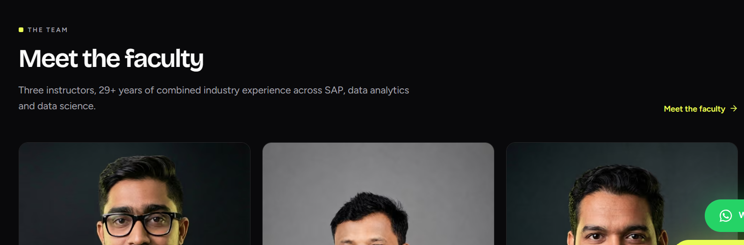
when we start this part on home page we have to first mention the directors both female
then following with Sudhir Shrwan sir as Mentors Sudhir As DATA Shrwan sir as SAP mentor with industry knowledge we don’t highlight them as trainer here. Then Vivek sir as Data Analytics, Data Science trainer in next section below mentor ad team there we will be adding trainers like vivek Abhinav ( adding there images below) then counsellors images then HR Placemnt team to show a mob you can also add yours here as Tech support or any relevant role with photos. Also try to uniform background for all the images I had subscription for Pro but it got expired. Try to do it if possible.
- Mayuri Deshmukh Career Counselor - Sakshi Wadaskar - Placement & HR Coordinator
https://www.linkedin.com/in/sakshi-wadaskar-4644651b2/
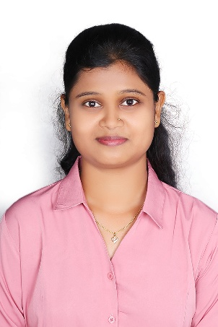
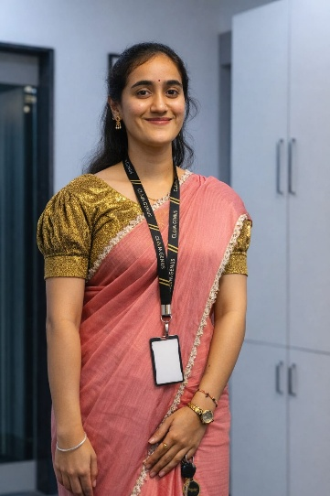

Abhinav Dusariwar – Data Analytics Data Science Trainer
https://www.linkedin.com/in/abhinav-dusariwar/
-
Anuj Kulkarni Placement & HR Coordinator

https://www.linkedin.com/in/anuj-kulkarni-98b7bb27b/


Vaishnavi Sonule – Career Counselor
https://www.linkedin.com/in/vaishnavi-sonule-7715a423a/

keep space blank create a card will share image for Vaishnavi

Operations Manager – Tejas chitriv Techinal Guy( rewrite the designation) Saurabh Radke
https://www.linkedin.com/in/tejas-chitriv-296971360/


Flow for the images will be
First section
Director 1 Director 2
Second Section
Mentor 1 Mentor 2
Team
Trainer 1 trainer 2 Counselor 1 counselor 2 Hr placement 1 Hr placement 2 Operations Manager

Change all to recent 2026 and highlight that these are some of fresh placements
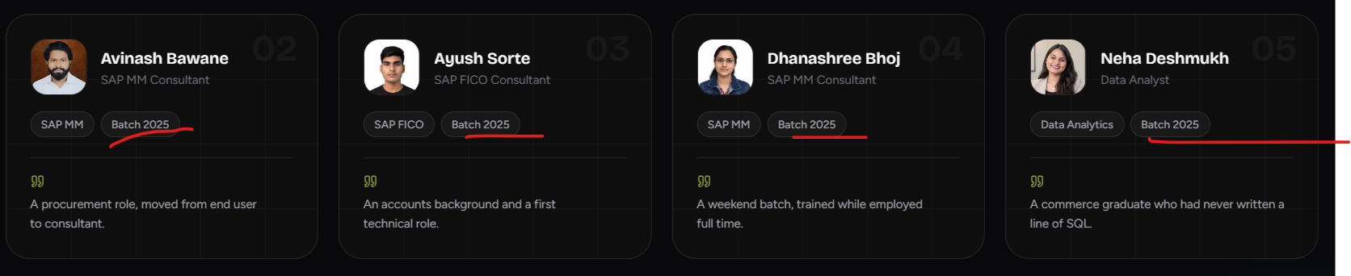

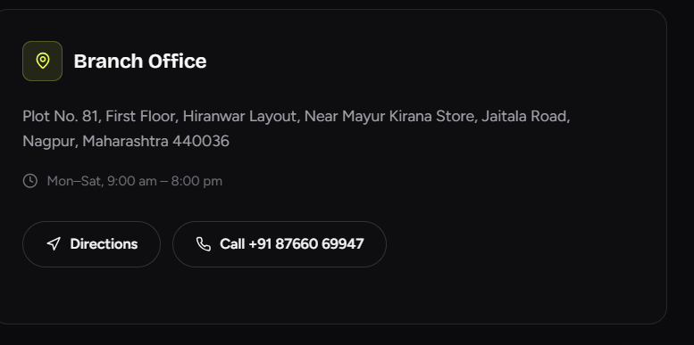
Change the branch office location - US Tower, Vasudev Nagar Metro Station, 1st Floor Above Ather Showroom 440016
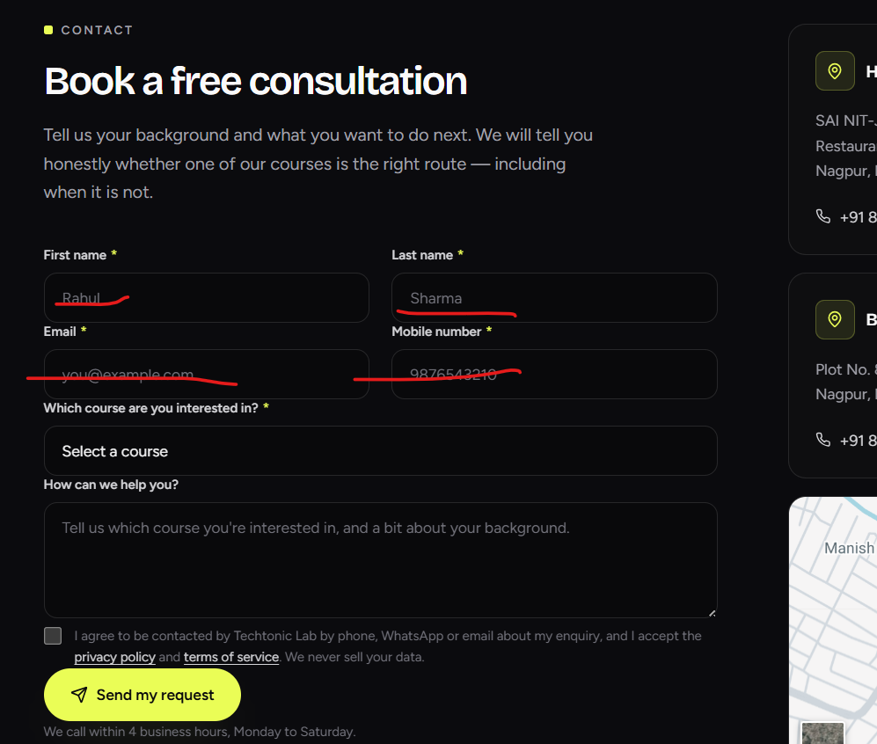

Remove this names number in blanks It shows some contact details filled
Hope you have redesigned the syallabus in the theme with logos and all for all modules SAP and Data everyone should be able to downloads the brochure directly from there once they fill the email in the blank refer the syllabus shared over whatspp

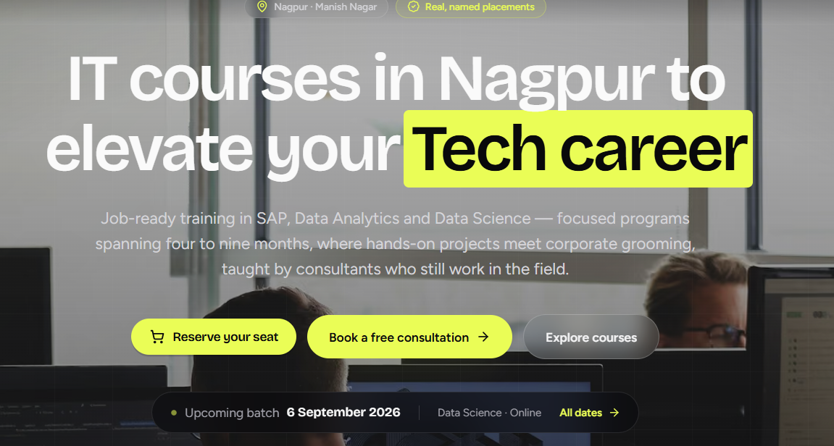
Make this look more cleaner narrow down the spread given to Tech Career also line spacing or font change whatever necessary to make it more cleaner.

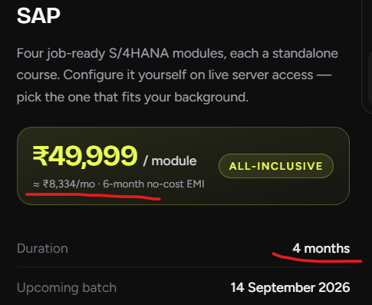
Make the emi split to only 3 20K + 15K +15K don’t mention upfront but write 3 iinstalmnets
same for Data Analytics duration 6 months for course as mentioned but payment to be maintained and completed in 3 months same 20 15-15 3 EMI’s
For Data Science duration is 9 months and payment to be paid in 6 months
Write a bigger number for Instructors like 12 directors 2 Combined Courses 6 Manish Nagar and Vasudev Nagar
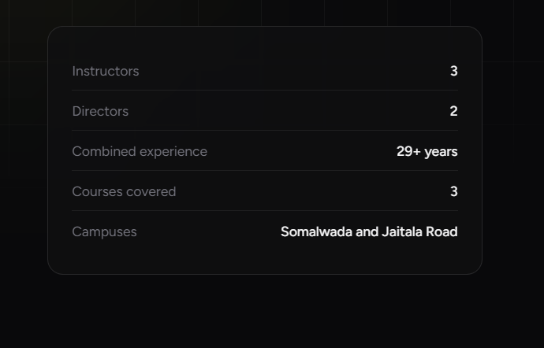
https://www.linkedin.com/in/dnyaneshwari-lanjewar-485912202/
Linkedin for Director Dnyaneshwari
Linkedin for Director Rupali https://www.linkedin.com/in/rupali-wankhede-170104253/
Follow the hierarchy as mentioned for directors then mentor then team likwise 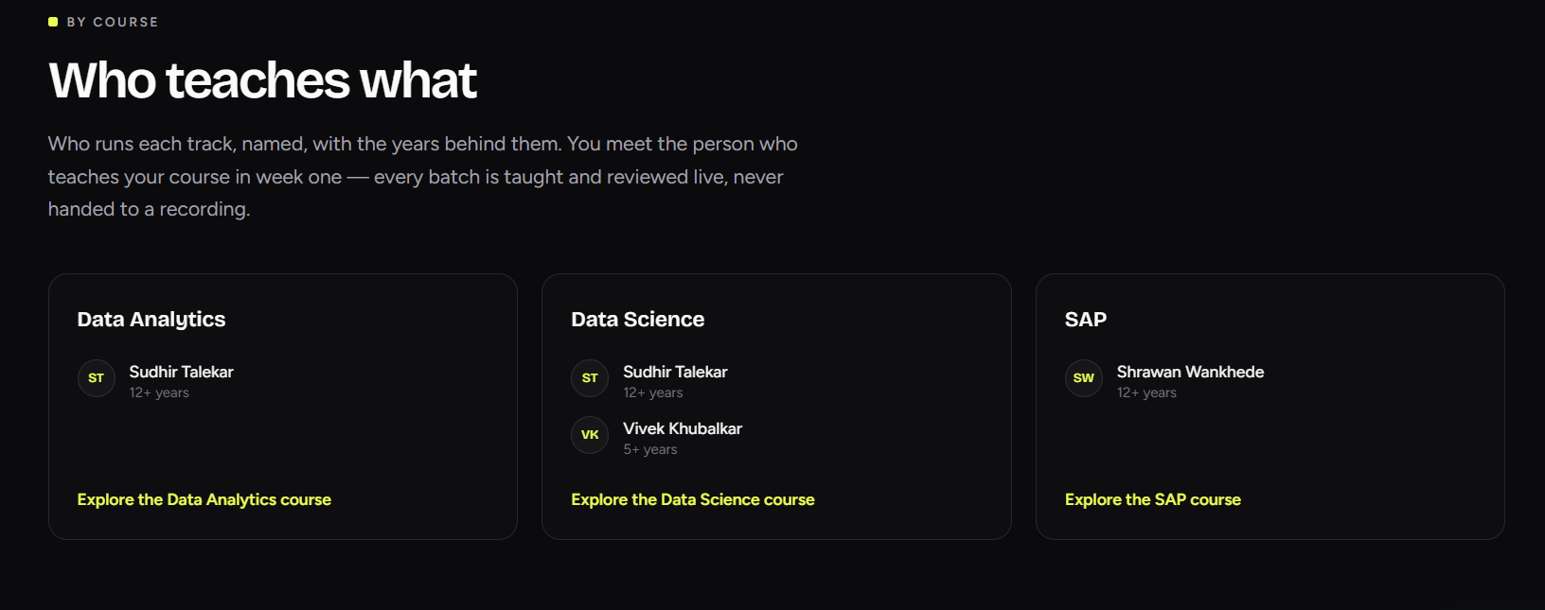

We can remove this part just in there profile mention them as mentors no specific allocation here
We have some sections specvifically created so mention Vivek sir and abhinav for Data Analytics and Data Science

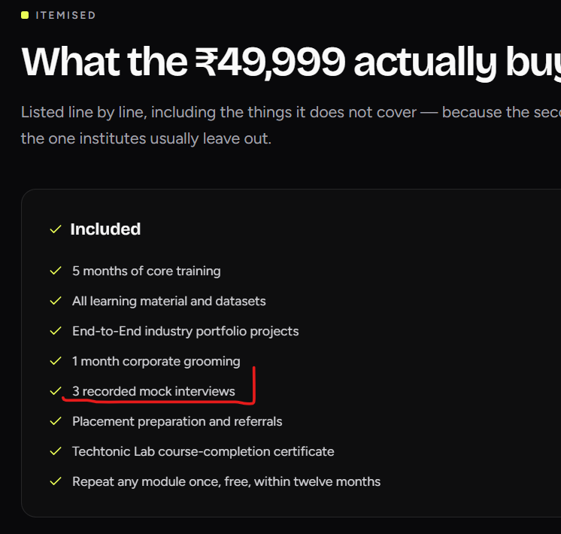
This is not recorded it will live mock interviews taken by Insutry experts who still work in senior level roles currently or are Hirng for this role from years
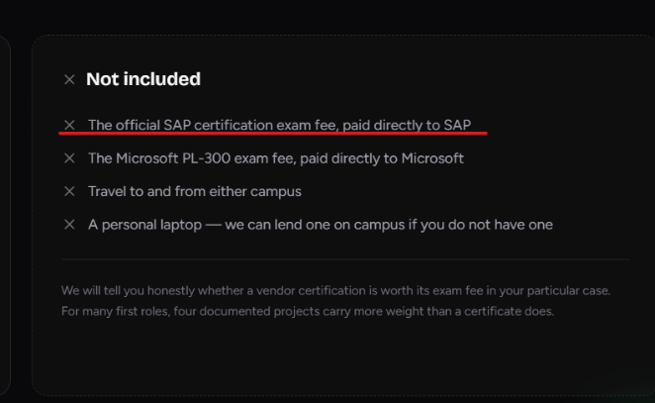
Remove this SAP certification cost part form Data what incudes part as SAP is not relevant for DATA here both are different the PL300 is rlevant

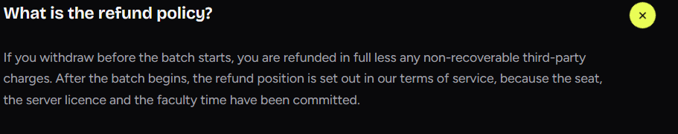
remove this point we have no refund once paid policy

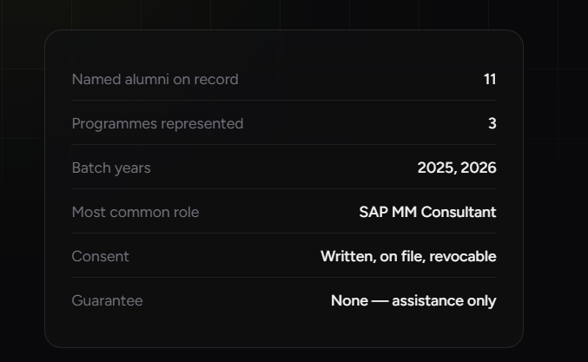
alumni on record 197-200 or any relevant number which ChatGPT suggest to look real 11 seems so less
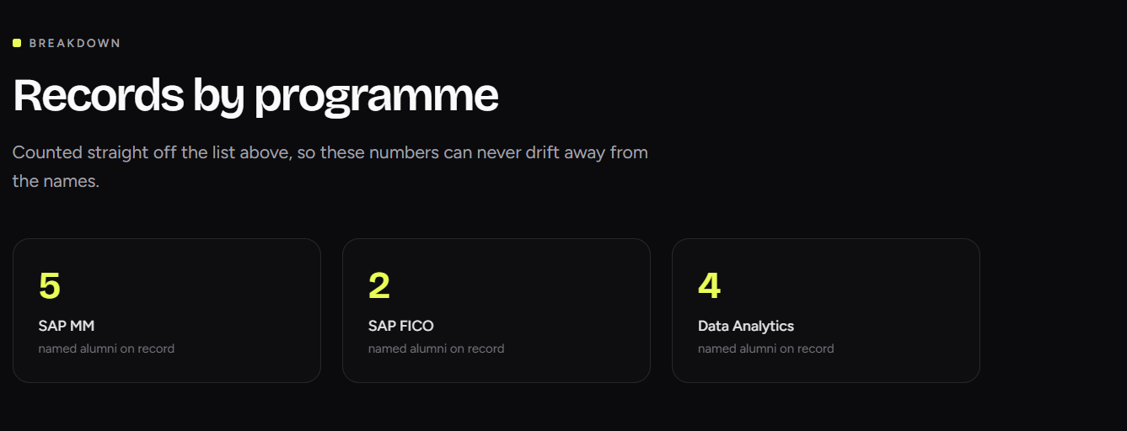
Add some weight here also number seems less

Add more companies here mid level and famous may be more and a box which states 18+ more other companies
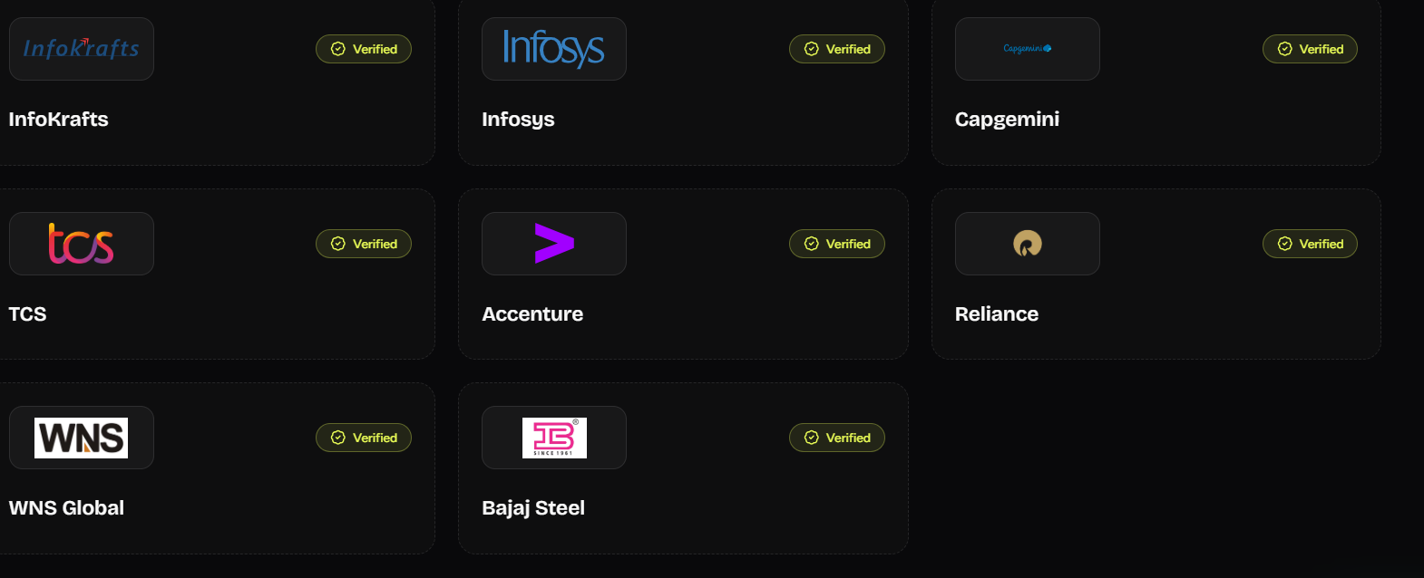

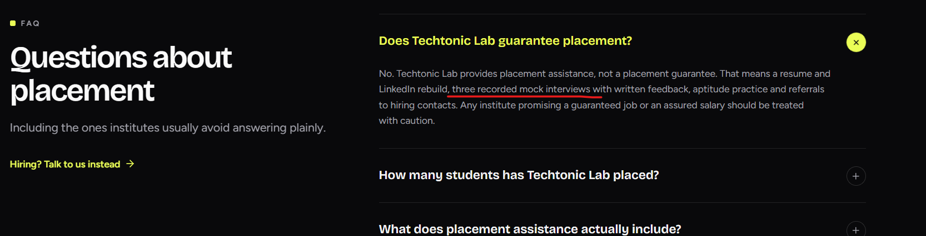
what do we mean by Three recorded Mock, Make it look like real interview experience with Industry expert interviewers not recorded scripted

